**GAS SENSOR CALIBRATION SYSTEM**

**DOCUMENTATION**

1. General Features 2

2. Overview gas sensing calibration cell 2

3. Owlstone ogv-4 interface 2

4. Probe temperature (monitoring and control) 2

5. Humidity (monitoring and control) 2

6. Gas sensing elements 2

7. Other sensors 2

8. Resistance data logger 2

9. Software and control 2

10. Other Features 2

1. **General Features**
2. **Overview gas sensing calibration cell**

O sistema de calibração de sensores gás deve ser capaz de caracterizar as propriedades de materiais semicondutores a partir da exposição programada e controlada aos gases de interesse. Para tanto, o sistema deve: 1) fornecer controle de temperatura simples e independente para cada sensor ou par de sensor, 2) fornecer controle de umidade e características do fluxo (umidade, temperatura e pressão), 3) usar sensores comerciais calibrados para a determinação da concentração real do gás de interesse no fluxo de arraste e 4) programar os ciclos de exposição/recuperação possibilitando ao usuário o controle sobre parâmetros experimentais como tempo de exposição e tempo de recuperação. Além do mais, o sistema deve controlar para que as medidas sejam realizadas independentemente do usuário de maneira automática e segura.

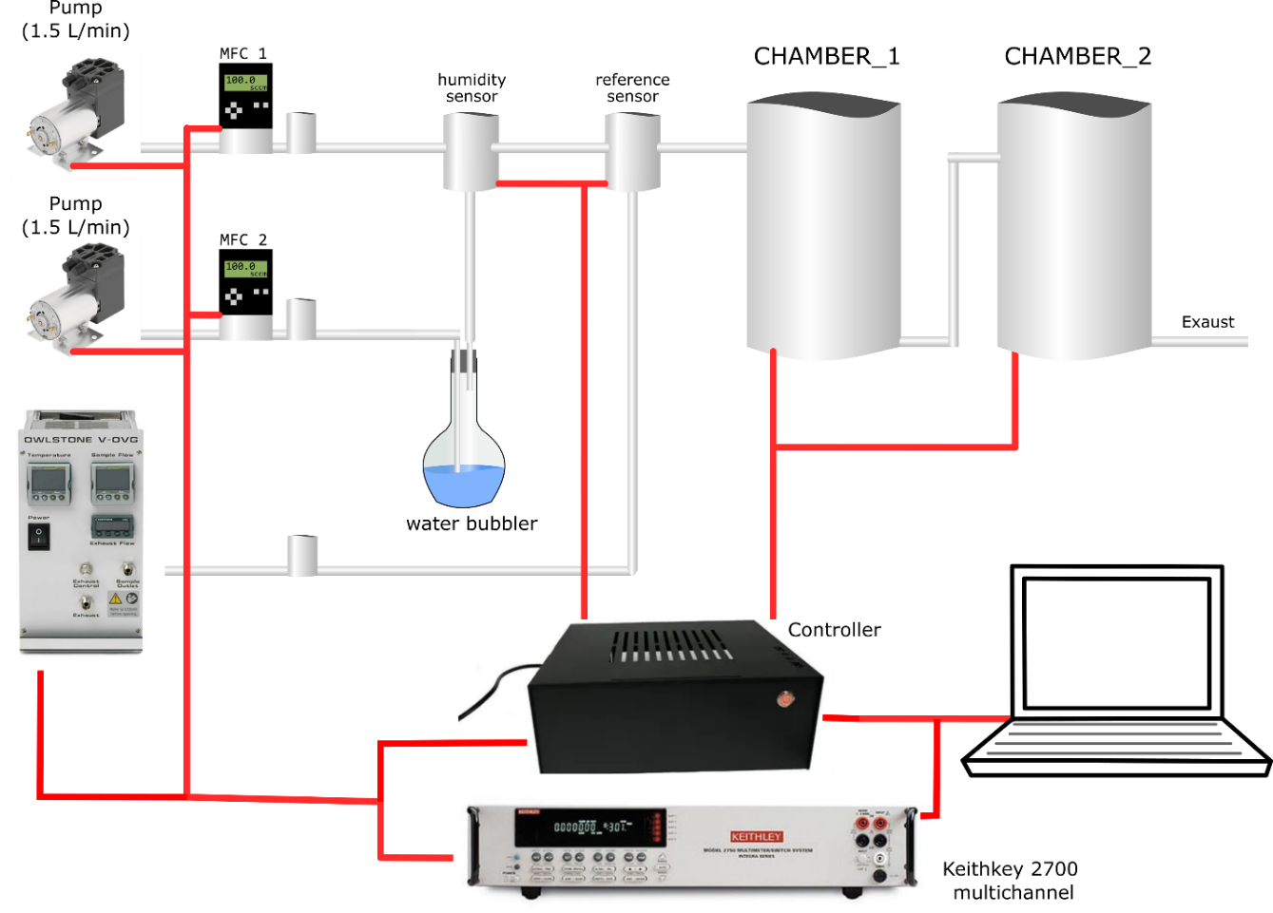

Figure 1. System overview

1. **Probe temperature (monitoring and control)**

**3.1 Probe temperature**

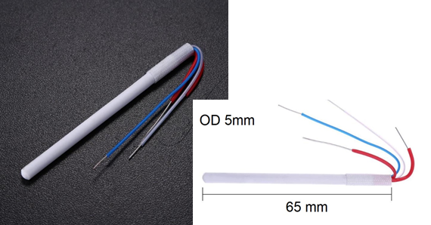

The probe temperature is built using a **“50W 24V Heating Element 1322”**. This element is used as Soldering Iron Ceramic Heater with 4-wire Heating Tool for Solder Iron Station for 936 937.

Figure 2. “50W 24V Heating Element 1322”. Available [**here**](https://www.aliexpress.com/item/33039642896.html?spm=a2g0s.9042311.0.0.27424c4dPp5weX).

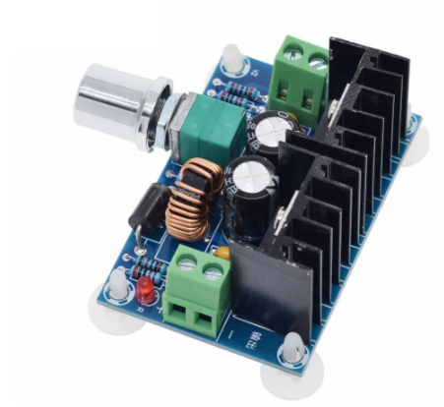

For the temperatures range we will use in our experiments, we will feed the heater with 12V from the voltage source and it can be adjusted by the user with the DC-DC voltage Regulator.

Figure 3. DC-DC voltage regulator. Available [**here**](https://www.aliexpress.com/item/1005002066656864.html?spm=a2g0o.productlist.0.0.4e4e42b8NIDLmu&algo_pvid=bd73daa2-df1d-4450-8726-19aba1687aa1&algo_exp_id=bd73daa2-df1d-4450-8726-19aba1687aa1-27&pdp_ext_f=%7B%22sku_id%22%3A%2212000018623766167%22%7D).

**Cable scheme for Cell connection**

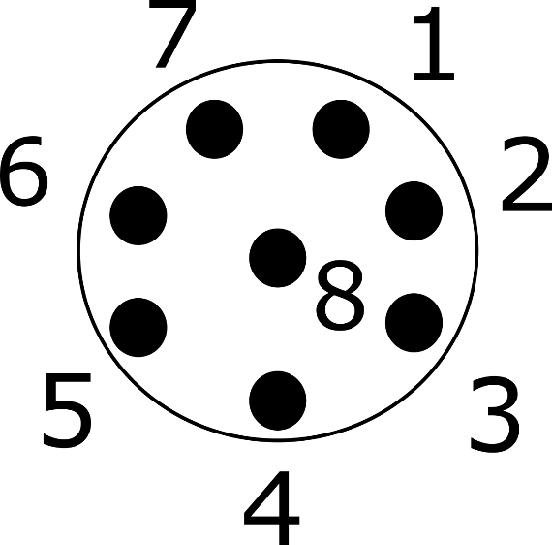

1 – Heater terminal 1 - RED

2 – **Sample 1** terminal 1 (Green wires inside the cell 1 and purple in the cell 2) - ORANGE

3 – **Sample 1** terminal 2 (Green wires inside the cell 1 and purple in the cell 2) - YELLOW

4 – **Sample 2** terminal 1 – (Yellow wires inside the cell 1 and blue in the cell 2) - GREEN

5 – **Sample 2** terminal 2 – (Yellow wires inside the cell 1 and blue in the cell 2) - BLUE

6 –Temperature Sensor positive terminal - PURPLE

7 – Temperature Sensor negative terminal - GREY

8 – Heater terminal 2 - BROWN

Heater ~ 10.8 ohms

Temperature Sensors ~ 0.9 Ohms

**Inside the cabinet**

1 – Heater terminal 1 - YELLOW

2 – **Sample 1** terminal 1 – GREEN

3 – **Sample 1** terminal 2 – GREEN

4 – **Sample 2** terminal 1 – BLUE

5 – **Sample 2** terminal 2 – BLUE

6 –Temperature Sensor positive terminal - PURPLE

7 – Temperature Sensor negative terminal - GREY

8 – Heater terminal 2 - BLACK

**3.2 Temperature sensor calibration**

1. **Humidity (monitoring and control)**

The flow humidity will be monitored with a Bosh BME 280 sensor. It will also measure the flow pressure and temperature. These values will be constantly updated in the “Flow Info” board and its values versus time can plotted by clicking the “Show” button. The BME 280 sensor is configured to normal mode and oversampling set to 1, 3 and 6 for pressure, temperature and humidity, respectively.

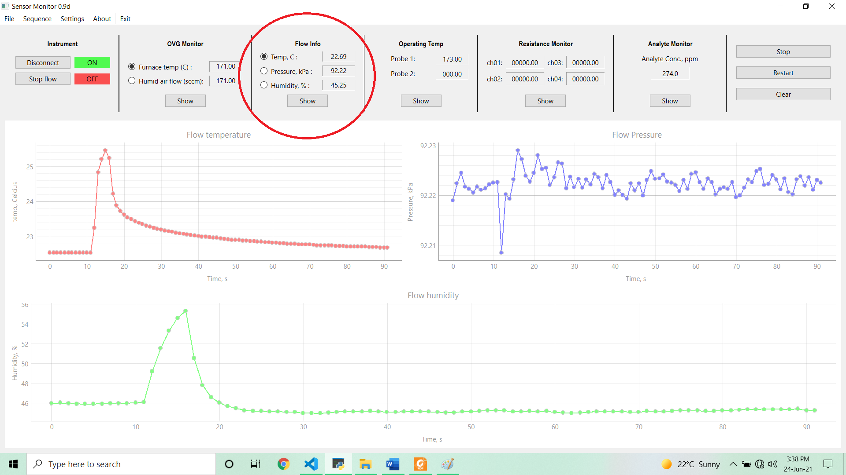

CABLE DESIGN – MIKE CONNECTOR G12 6 wires

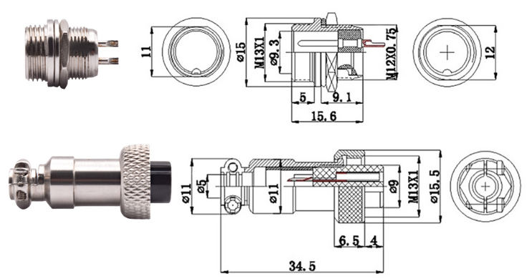 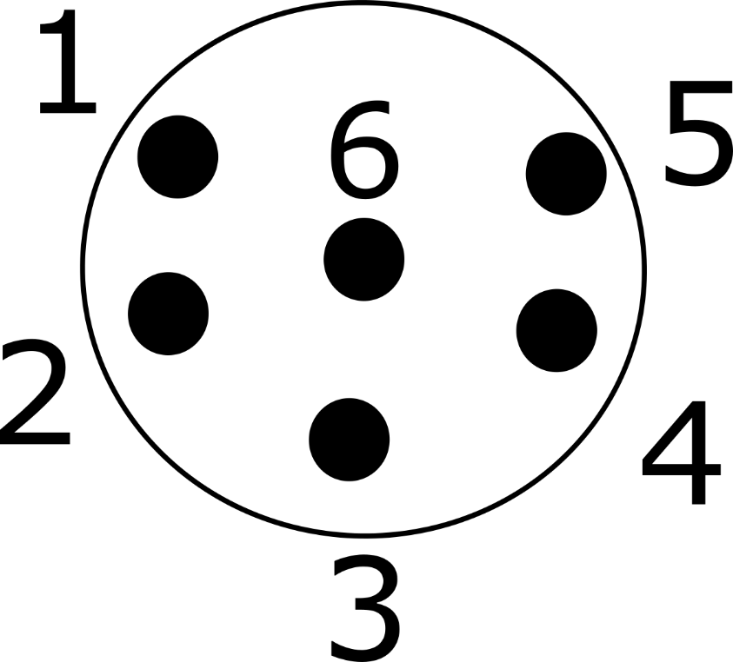

1 SCL (BLUE)

2 SDA (WHITE)

4 GND (BLACK/BROWN)

5 VCC (RED)

**Gas sensing elements**

CABLE FOR MICS 5524 and MICS 6814

CABLE DESIGN – MIKE CONNECTOR G16 8 wires

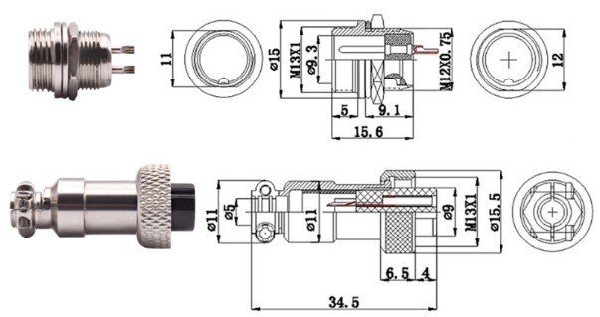 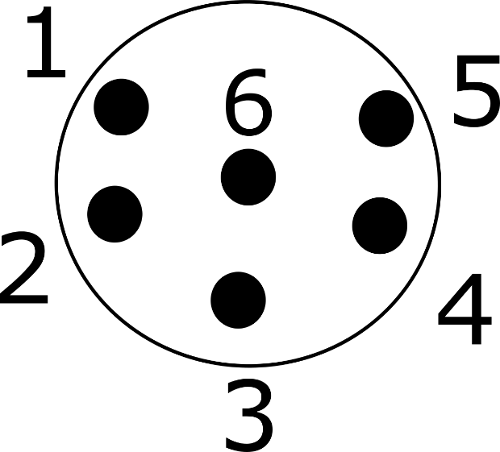

1 MICS 6814 – CO (PURPLE)

2 MICS 6814 – NH3 (BLUE)

3 MICS 6814 – NO2 (GREEN)

4 GND (BLACK/GREY)

5 VCC (RED/BROWN)

6 MICS 5524 – A0 (YELLOW)

1. **Exposure valve control**
2. **Other sensors**
3. **Resistance data logger**

The system is capable of reading voltage with an analog-digital-converter integrated circuit ADS1115. With this IC we can reach different levels of resolution, according to the maximum value of voltage that shall be read. For this interface, we are using the ADAFRUIT ADS_1X15.h library.

According to this library:

The ADC input range (or gain) can be changed via the following functions, but be careful never to exceed VDD +0.3V max, or to exceed the upper and lower limits if you adjust the input range. Setting these values incorrectly may destroy your ADC!

|  |  |  |  |  |
| --- | --- | --- | --- | --- |
| **Command** | **Gain** | **Voltage limits** | **1 bit**  **ADS1015** | **1 bit**  **ADS1115** |
| ads.setGain(GAIN_TWOTHIRDS); | 2/3x | +/- 6.144V | 3 mV | 0.1875 mV |
| ads.setGain(GAIN_ONE); | 1x | +/- 4.096V | 2 mV | 0.125 mV |
| ads.setGain(GAIN_TWO); | 2x | +/- 2.048V | 1 mV | 0.0625 mV |
| ads.setGain(GAIN_FOUR); | 4x | +/- 1.024V | 0.5 mV | 0.03125 mV |
| ads.setGain(GAIN_EIGHT); | 8x | +/- 0.512 V | 0.25 mV | 0.015625 mV |
| ads.setGain(GAIN_SIXTEEN); | 16x | +/- 0.256 V | 0.125 mV | 0.0078125 mV |

Our measurements are carried out by keeping a constant current flowing through two terminals and to read the voltage drop between these two terminals (differential reading mode) or between one terminal and the ground (normal reading mode). The circuit designed to read the resistance of the probe temperatures keeps a current of approximately 1.25 mA, with a voltage source of 3.3 mV. Consequently, it will read values up to 800 Ω with a resolution of 0.125 mV. The circuit is designed as follows:

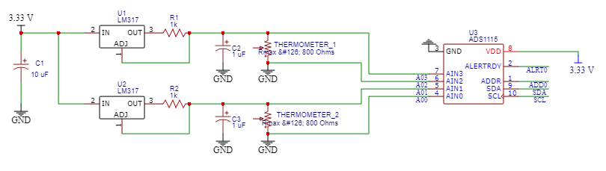

Fig 7. Schematic of the Resistance datalogger in the differential mode

1. **Software and control**
2. **Other Features**